

SOFTWARE REQUIREMENT SPECIFICATION
Project Name (Code)

– Hanoi, Jan 2024 –
Table of Contents
I. Record of Changes 3
II. Software Requirement Specification 4
1. Overall Requirements 4
1.1 Context Diagram 4
1.2 Main Business Processes 5
1.3 User Requirements 5
1.4 System Functionalities 7
1.5 Entity Relationship Diagram 7
2. Use Case Specifications 8
2.1 <<Feature Name1>> 8
2.2 Xyz Feature 10
3. Functional Requirements 11
3.1 Feature Name1 11
3.2 User Authentication 11
3.3 System Administration 12
4. Non-Functional Requirements 13
3.1 External Interfaces 13
3.2 Quality Attributes 13
5. Requirement Appendix 14
5.1 Business Rules 14
5.2 System Messages 14
5.3 Other Requirements… 15

I. Record of Changes
Date | A*  M, D | In charge | Change Description
*A - Added M - Modified D - Deleted

II. Software Requirement Specification

1. Overall Requirements

1.1 Context Diagram
[Gives the overall description about the product with some introduction and the context diagram. The context diagram presents the boundary and connections between the system you’re developing and everything else in the universe. This identifies external entities (or terminators – software, hardware, human components, and other systems) outside the system that interface to it in some way, as well as data, control, and material flows between the terminators and the system.]
<<Sample: The Cafeteria Ordering System is a new software system that replaces the current manual and telephone processes for ordering and picking up meals in the Process Impact cafeteria. The context diagram below illustrates the external entities and system interfaces for release 1.0. The system is expected to evolve over several releases, ultimately connecting to the Internet ordering services for several local restaurants and to credit and debit card authorization services.
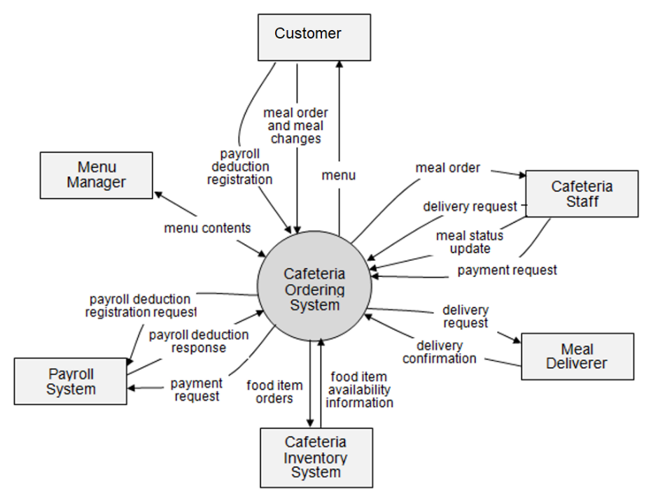
>>

1.2 Main Business Processes
[Provide main workflows (business processes) using the swim-lane diagram(s) like sample below]

1.2.1 Order Processing
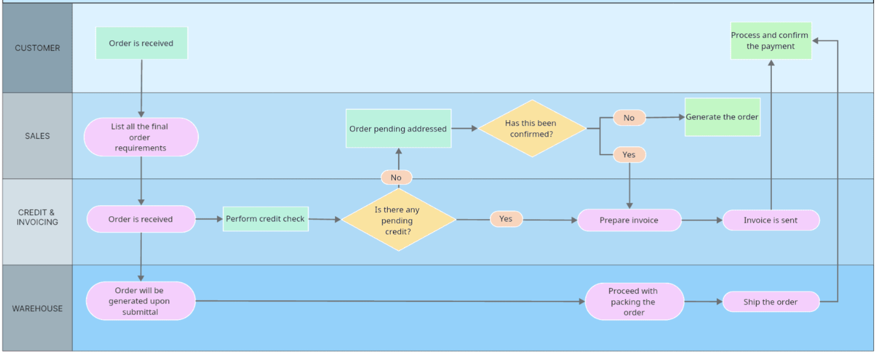

1.2.2 Customer Support
…

1.3 User Requirements

1.3.1 Actors
[An actor is someone/something that interacts with the system.
- The only external entities that interact with the system
- ﻿Actors are outside the system and not part of it
- ﻿A user is an individual, whereas an actor represents the role played by all users of the same type
- There are other types of actors in addition to or in place of human actors: external systems, I/O devices, or timers
Following are some questions you might ask to help user representatives identify actors
- Who (or what) is notified when something occurs within the system?
- Who (or what) provides information or services to the system?
- Who (or what) helps the system respond to and complete a task?
This part gives the description of system actors, you can follow the table form as below]
# | Actor | Description
1 | Administrator | Actor description here..
2 | Menu Manager | ..
3 | …

1.3.2 Use Cases (UC)
[A use case (UC) describes a sequence of interactions between a system and an external actor that results in the actor being able to achieve some outcome of value. The names of use cases are always written in the form of a verb followed by an object. Select strong, descriptive names to make it evident from the name that the use case will deliver something valuable for some user.
Following are some questions you might ask to help user representatives identify use cases
- What will the actor use the system for?
- Will the actor create, store, change, remove, or read data in the system?
- Will the actor need to inform the system about external events or changes?
- Will the actor need to be informed about certain occurrences in the system?
This part describes the use cases you could define, you can follow the table form as below]
ID | Use Case | Feature | Use Case Description
01 | View Menu | Feature Name1
02 | Order a Meal | Feature Name2
03 | …
…

1.3.2 Use Case Diagrams
In this section, you need to provide the UC diagram(s) to show the actor-UCs and UC-UC relationships like the sample below. You can have multiple UC diagrams for the system, each diagram is for one actor or one workflow]

1.3.2.1 UCs for Guest
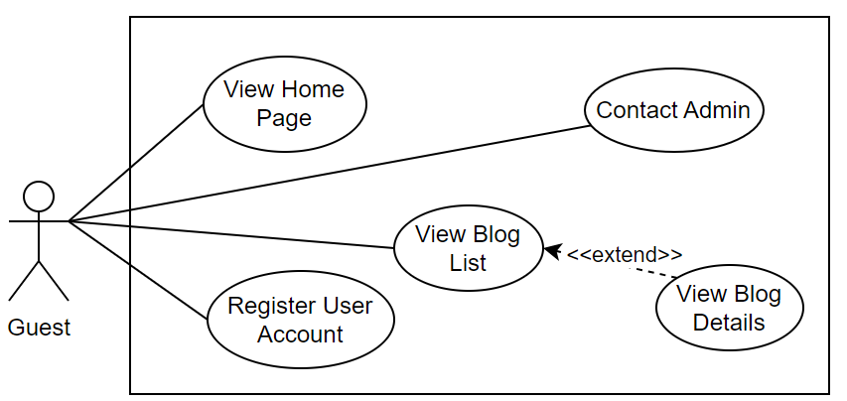

1.3.2.2 UCs for Student
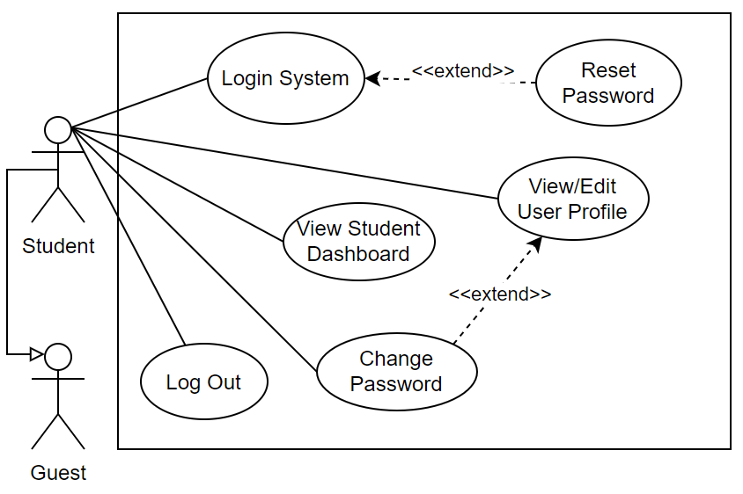

1.3.2.3 …

1.4 System Functionalities
[Provide functionality overview of software system: screen flow, screen descriptions, system user roles, screen authorization, non-screen functions, ERD]

1.4.1 Screens Flow
[This part shows the system screens and the relationship among screens. You can draw the Screens Flow for the system in the form of diagram as below.]
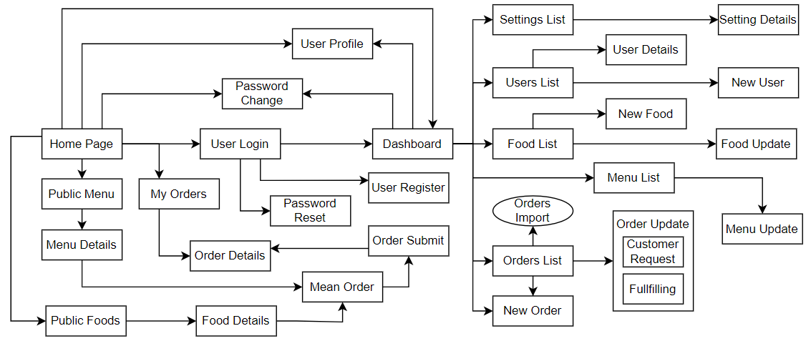

1.4.2 Screen Authorization
[Provide the system roles authorization to the system features (down to screens, and event to the screen activities if applicable) in the table form as below – replace Role-Name1, Role-Name2,… with your specific system user role names]
Screen | Role-Name1 | Role-Name2 | Role-Name3 | …
<<Screen Name1>> | X |  | X | X
<<Screen Name2>> |  | X
…

1.4.3 Non-UI Functions
[Provide the descriptions for the non-screen system functions, i.e batch/cron job, service, API, etc.]
# | Feature | System Function | Description
1 | <<Feature Name>> | <<Function Name1>> | <<Function Name1 Description>>
2 | …

1.5 Entity Relationship Diagram
[Provide the ERD using the Crow-Foot notation and the entity descriptions as below]
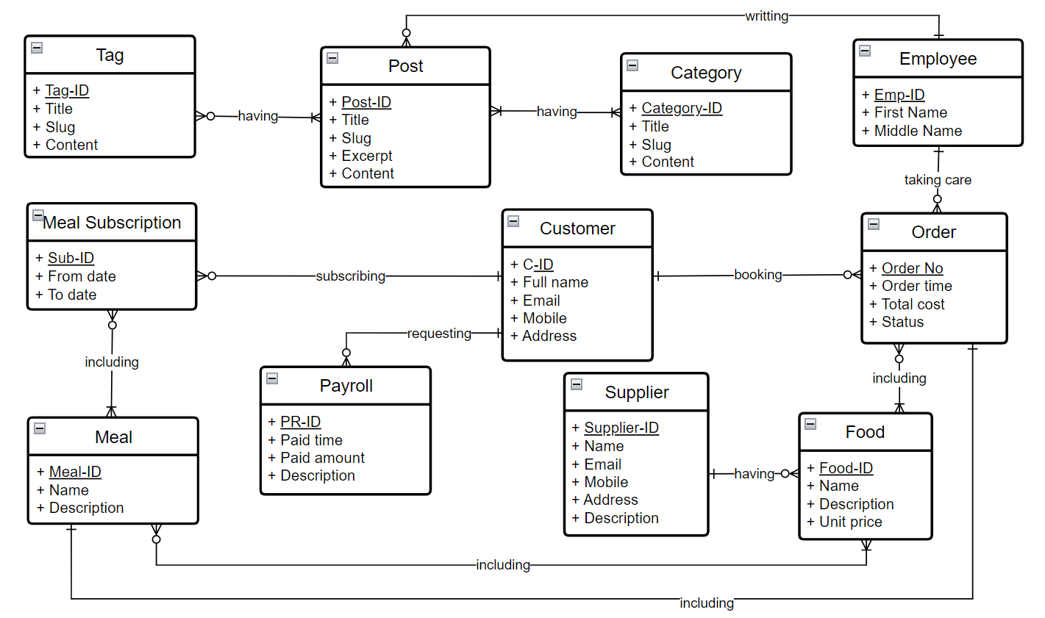
Entities Description
# | Entity | Description
1 | Patrol | Cafeteria’s customer information
2 | Meal | …
3 | …

2. Use Case Specifications
Primary Actors |  | Secondary Actors
Description
Preconditions
Postconditions
Normal Sequence/Flow
Alternative Sequences/Flows
Primary Actors | Customer | Secondary Actors | None
Description | As a user, I want to be able to log into the system so that I can use the system’s authenticated features and access my personalized account.
Preconditions | User account has been created & authorized
Postconditions | - User logs in the system successfully  - The system tracked successful login into the Activity Log
Normal Sequence/Flow | Login System  - User clicks Login button from the page header or accesses an authenticated feature (from a link or type the page URL directly into the address bar)  - System show the User Login screen  - User types in the login details (email, password)  - User clicks the Login button  - System validates the login details (BR-01, BR-02)  - System allows user to access  - System tracks user’s success login to the Activity Log  - System directs user to the Home Page (or the previous calling page if any)
Alternative Sequences/Flows | Step 2.1_Google Login  - User clicks Google Login button to login system using Google account  - System redirects the user to the Google’s Login screen  - User types in the Google account details and chooses to login  - Google validates user’s login information successfully and redirect him/her back to the system  - Return to step 5 of normal flow.  Step 4_System can’t authenticate the user  User can’t be authenticated & get relevant error message in one of below cases  - He/she leaves the Email and/or Password field blank (MSG10)  - Input Email or Password are incorrect (MSG09)  - Input Email/Password are correct but email has not been verified (MSG11)  - The user account is blocked / inactive (MSG12)  If user inputs wrong logging-in details 5 times continuously, system will lock his/her account in 30 minutes (with relevant warning message - MSG13)

3. Functional Requirements
[Provide descriptions about the system’s functions/screens. The functions/screens are grouped by the system features, and even sub-features if needed. For the screens, you need to provide the screen layouts (mock-up screens) and relevant specifications if needed]

3.1 Feature Name1

3.1.1 SubFeature Name1.1

3.1.1.1 Screen/Function Name1
[Content #1: UI layout (Mockup screen prototype)]
[Content #2: brief descriptions of the screen/function, mapped to the relevant use cases]
[Content #3: provide further descriptions for the screen’s components/fields using table format below]
Field Name | Description
Field Name1 | Field description: data type min/max length or value, initial data, etc.
Field Name2 | …
Field Group-Name1
Field Name3 | …
Field Name4 | …
Field Group-Name2
… | …

3.1.1.2 Screen/Function Name2
…

3.1.2 SubFeature Name1.2
…

3.2 User Authentication

3.2.1 User Register
…

3.2.2 User Login
…

3.2.3 Password Reset
…

3.3 System Administration

3.3.1 Master Data

3.3.1.1 Setting List
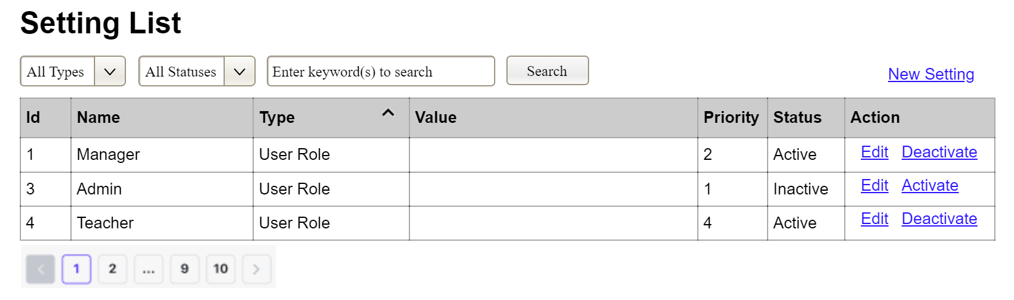
(1)
(2)
(3)
This screen allows the Administrator to:
- View Setting List: view list of current master data.

2.1 Authentication & Account Management

2.1.1 User Registration (Freelancer/Employer)
Primary Actors: Guest User
Secondary Actors: System Database, Email Service (OTP)
Description: As a guest user, I want to register a new account as either a Freelancer or an Employer so that I can access personalized features within the marketplace.
Preconditions:
The user must provide an email address that does not already exist in the system.
Postconditions:
A new unverified `User` record is created in the database with status `PENDING`.
An OTP is generated and sent to the provided email address via the Email Service.
Normal Sequence/Flow:
1. User accesses the "Sign Up" page.
2. User selects the account type: "I am a Freelancer" or "I am an Employer".
3. User enters required details: Full Name, Email, Password, and Confirm Password.
4. User clicks "Create Account".
5. System validates the inputs (e.g., password strength, matching passwords, valid email format).
6. System checks the `users` table to ensure the email is unique.
7. System hashes the password (e.g., using BCrypt) and stores the new user record.
8. System generates a 6-digit OTP, stores it in the cache/database with an expiration time (e.g., 5 minutes), and invokes the Email Service to send it to the user.
9. System redirects the user to the "OTP Verification" screen.
Alternative Sequences/Flows:
Step 5a - Invalid Input Format: System highlights the invalid fields and displays inline validation errors (MSG02).
Step 6a - Email Already Exists: System displays an error message (MSG08): "This email is already registered."

2.1.2 User Login
Primary Actors: Registered User (Freelancer, Employer, Staff, Manager, Admin)
Secondary Actors: System Auth Context (JWT)
Description: As a registered user, I want to log into the system using my credentials so that I can securely access my authorized dashboard.
Preconditions: The user's account must exist and be in an "ACTIVE" state (email verified, not banned).
Postconditions: A valid JWT access token is generated and returned to the client.
Normal Sequence/Flow:
1. User navigates to the "Login" page.
2. User inputs Email and Password, then clicks "Login".
3. System verifies the credentials against the database.
4. System checks the user's current status (Must be "ACTIVE").
5. System generates a JWT payload containing the User ID, Role, and expiration timestamp.
6. System updates the `last_login_at` timestamp for the user.
7. System returns the JWT to the client and redirects the user to their respective role-based dashboard.
Alternative Sequences/Flows:
Step 3a - Incorrect Credentials: System returns a generic error (MSG09): "Incorrect username or password. Please check again."
Step 4a - Unverified Email: System detects the account is `PENDING` and prompts the user to verify their email, offering a "Resend OTP" link.
Step 4b - Banned Account: System prevents login and displays a specific warning: "Your account has been suspended. Please contact support."

2.2 Project & Proposal Management

2.2.1 Post a Job
Primary Actors: Employer
Secondary Actors: System Database
Description: As an Employer, I want to post a new project/job so that I can attract and receive proposals from qualified Freelancers.
Preconditions:
The Employer is authenticated and active.
The Employer has sufficient funds or a valid subscription package (if applicable).
Postconditions: A new `Project` record is created in the database with status `OPEN`.
Normal Sequence/Flow:
1. Employer navigates to the "Post a Job" screen.
2. Employer fills in project details: Title, Description, Required Skills, Budget Range, Timeline, and Job Category.
3. Employer clicks "Publish Project".
4. System validates all mandatory fields and budget constraints (e.g., Min Budget > 0).
5. System creates the `Project` entity and maps it to the Employer.
6. System displays a success message (MSG04) and redirects the Employer to the Project Details page.
Alternative Sequences/Flows:
Step 4a - Invalid Budget: System displays an error if the maximum budget is lower than the minimum budget.

2.2.2 Submit a Proposal
Primary Actors: Freelancer
Secondary Actors: Employer (Receiver)
Description: As a Freelancer, I want to submit a customized proposal to an open project to offer my services to the Employer.
Preconditions:
The Freelancer is authenticated.
The target Project is in `OPEN` status.
The Freelancer has not already submitted a proposal for this project.
Postconditions: A new `Proposal` record is created and linked to the Project and the Freelancer.
Normal Sequence/Flow:
1. Freelancer views the details of an `OPEN` project and clicks "Submit Proposal".
2. System displays the proposal form.
3. Freelancer enters their Bid Amount, Estimated Duration, and a Cover Letter.
4. Freelancer clicks "Submit".
5. System validates the bid amount (cannot exceed the project's max budget) and the duration.
6. System saves the proposal to the database with status `PENDING`.
7. System generates a notification to the project's Employer.
8. System displays a success toast message (MSG04).
Alternative Sequences/Flows:
Step 1a - Already Proposed: System disables the "Submit Proposal" button and displays a badge indicating "Proposal Submitted".

2.2.3 Accept Proposal & Start Project
Primary Actors: Employer
Secondary Actors: Freelancer
Description: As an Employer, I want to accept a specific proposal and initiate an Escrow payment to formally start the project.
Preconditions:
The Employer is the owner of the Project.
The Project is `OPEN`.
The chosen Proposal is `PENDING`.
Postconditions:
The Proposal status changes to `ACCEPTED`.
All other pending proposals for this project are automatically marked as `REJECTED`.
The Project status changes to `IN_PROGRESS`.
The agreed funds are locked in Escrow.
Normal Sequence/Flow:
1. Employer reviews proposals on their project dashboard.
2. Employer selects a proposal and clicks "Hire/Accept".
3. System prompts the Employer to confirm and proceed to the Escrow payment screen.
4. Employer completes the payment process (via System Wallet or Gateway).
5. System verifies the funds.
6. System updates the Proposal and Project statuses.
7. System notifies the selected Freelancer that they have been hired.
Alternative Sequences/Flows:
Step 5a - Insufficient Funds: System aborts the acceptance process and redirects the Employer to the Wallet Top-up screen.

2.3 Payment & Invoice Management

2.3.1 Dynamic Payment Sync (System Function)
Primary Actors: System
Secondary Actors: Employer
Description: The payment system dynamically synchronizes with changes in service package configurations to ensure users are billed the exact, real-time configured amount at checkout.
Preconditions: Service package prices have been set by the Admin in the `ServicePackageConfig` table.
Postconditions: The payment link is generated using the exact database-driven price.
Normal Sequence/Flow:
1. Employer selects a package (e.g., "PREMIUM") and clicks "Pay Now".
2. System receives the checkout request containing the `packageType`.
3. System queries the `ServicePackageConfig` table for the EXACT CURRENT price of the requested `packageType`.
4. System initializes a `PaymentTransaction` using this retrieved price, intentionally ignoring any price data submitted by the client-side to prevent payload tampering.
5. System forwards the exact amount to the Payment Gateway SDK to generate the payment URL.
6. System redirects the Employer to the Gateway.
Alternative Sequences/Flows:
Step 3a - Package Not Found: System throws an `IllegalArgumentException` and aborts the transaction (HTTP 400).

2.3.2 Generate Payment Invoice (System Function)
Primary Actors: Payment Gateway (Webhook/IPN)
Secondary Actors: Administrator, Employer
Description: The system automatically generates a payment invoice upon receiving a successful transaction callback from the Payment Gateway.
Preconditions: A `PaymentTransaction` exists in a `PENDING` state.
Postconditions: A `PaymentInvoice` record is created, and the transaction is marked `SUCCESS`.
Normal Sequence/Flow:
1. System receives an IPN (VNPay) or Webhook (PayOS) callback with a Success response code.
2. System verifies the cryptographic signature of the callback payload (BR-33).
3. System locates the corresponding `PENDING` transaction.
4. System invokes the `InvoiceService` to generate a new invoice.
5. System creates a `PaymentInvoice` record containing: `invoice_number`, `amount`, `tax_amount`, `total_amount`, and `status = PAID`.
6. System marks the transaction as `SUCCESS` and commits to the database.
Alternative Sequences/Flows:
Step 2a - Invalid Signature: System rejects the payload and logs a potential security incident.
Step 3a - Idempotency Check Failed: If the transaction is already `SUCCESS`, the system ignores the duplicate webhook to prevent duplicate invoice generation.

2.4 Chat & Notification

2.4.1 Send Real-time Message
Primary Actors: Freelancer, Employer
Secondary Actors: WebSocket Server
Description: As a user, I want to send real-time text messages to my project counterparts to discuss requirements and negotiate terms securely.
Preconditions: Both users must have an active message thread (usually initiated after a proposal is submitted).
Postconditions: The message is saved to the database and broadcasted to the recipient in real-time.
Normal Sequence/Flow:
1. User opens the Chat interface and selects a contact thread.
2. User types a message into the input field and presses "Send".
3. The client application emits the message payload via the active WebSocket connection.
4. System intercepts the message, validates the user's session token, and ensures the user has permission to message the recipient.
5. System persists the message record in the `messages` table.
6. System broadcasts the message event to the recipient's connected WebSocket channel.
7. Recipient's UI updates instantly to display the new message.
Alternative Sequences/Flows:
Step 4a - Unauthorized Messaging: If the user is blocked or has no active relation with the recipient, the system drops the WebSocket message and returns an error payload.

2.5 Admin & Department Management

2.5.1 Transfer Personnel
Primary Actors: Administrator
Secondary Actors: System Database
Description: As an Administrator, I want to transfer personnel (Staff or Manager) to other departments to dynamically allocate human resources.
Preconditions: The Administrator is authenticated with the "ADMIN" role.
Postconditions: The personnel's department is updated, and an audit trail is created.
Normal Sequence/Flow:
1. Administrator accesses the "Personnel Management" screen.
2. Administrator clicks the "Transfer" action on a specific personnel record.
3. System displays the "Transfer Personnel" dialog.
4. Administrator selects a destination department, enters a mandatory "Reason for transfer", and confirms.
5. System validates that the Destination Department differs from the Current Department.
6. System updates the personnel's `department_id` in the database.
7. System logs the action into the `department_transfer_history` table (capturing `user_id`, `from_department_id`, `to_department_id`, `transferred_by`, and `reason`).
8. System displays a success toast message (MSG03).
Alternative Sequences/Flows:
Step 5a - Same Department Selected: System displays an inline error (MSG08): "The destination department must be different from the current department."

2.5.2 Manage Service Packages
Primary Actors: Administrator
Secondary Actors: None
Description: As an Administrator, I want to update the price configurations for service packages to execute dynamic pricing strategies.
Preconditions: The Administrator is authenticated with the "ADMIN" role.
Postconditions: The `ServicePackageConfig` table is updated.
Normal Sequence/Flow:
1. Administrator navigates to the "Service Packages Configuration" screen.
2. Administrator inputs new price values for the desired packages (e.g., MEDIUM, REGULAR, PREMIUM).
3. Administrator clicks "Save Changes".
4. System validates that the input values are positive numbers.
5. System updates the prices in the database and records the `updated_at` timestamp.
6. System displays a success toast message (MSG03).
Alternative Sequences/Flows:
Step 4a - Negative or Zero Price: System displays an inline error (MSG08): "Price must be greater than 0."
- Filter Setting List: filter master data by data types, statuses
- Search Settings: enter keyword(s) to search master data by their names or values
- Sort Setting List: sort master data list (ascending, descending) by clicking column headers
On the screen, s/he can also
- Activate/Deactivate Setting: change status of a specific inactive/active master data
- Choose to go to the Setting Details screens for adding new or updating an existing master data by clicking the New Setting or Edit link.
Field Description
Field Name | Description
(1) | Initial values: all the active setting names with null or blank type  Hover the mouse to show the field name: “Setting Type”
(2) | Initial values: All Statuses, Active, Inactive (default value “All Status”)  Hover the mouse to show the field name: “Setting Status”
(3) | The change-status action is Activate or Deactivate depending on the current status of the relevant setting (Inactive or Active, respectively).

3.3.1.2 Setting Details
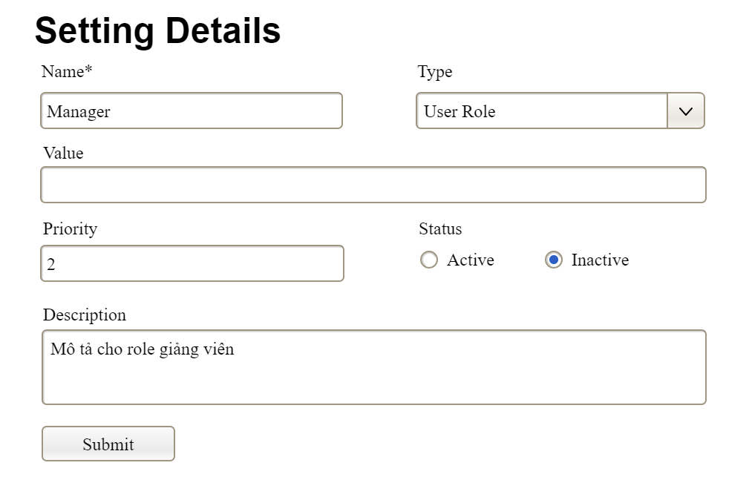

This screen allows the Administrator to:
- Add New Setting: add new master data.
- Update Setting Details: update details of a specific master data
Field Description
Field Name | Description
Name | Data type: non-digit string, max length of 20 characters
Type | Initial data values: all active setting names (with null or blank type)
Value | Data type: any string, max length of 100 characters
Priority | Data type: a positive integer
Description | Data type: any string, max length of 200 characters

3.3.2 User Management

3.3.2.1 User List
…

3.3.2.2 User Details
…

4. Non-Functional Requirements

3.1 External Interfaces
[This section provides information to ensure that the system will communicate properly with users and with external hardware or software/system elements.]

3.2 Quality Attributes
[List all the required system characteristics (quality attributes) specification. Some of the possible attributes are provided with the guide/descriptions are mentioned here]

3.2.1 Usability
[This section includes all those requirements that affect usability. For example, specify the required training time for a normal user and a power user to become productive at particular operations specify measurable task times for typical tasks or base the new system’s usability requirements on other systems that the users know and like specify requirement to conform to common usability standards, such as IBM’s CUA standards Microsoft’s GUI standards]

3.2.2 Performance
[The system’s performance characteristics are outlined in this section. Include specific response times. Where applicable, reference related Use Cases by name.
Response time for a transaction (average, maximum)
Throughput, for example, transactions per second
Capacity, for example, the number of customers or transactions the system can accommodate
Resource utilization, such as memory, disk, communications, and so forth.]

3.2.3 …

5. Requirement Appendix
[Provide business rules, common requirements, or other extra requirements information here]

5.1 Business Rules
[Provide common business rules that you must follow. The information can be provided in the table format as the sample below]
ID | Rule Definition
BR-01 | Delivery time windows are 15 minutes, beginning on each quarter hour.
BR-02 | Deliveries must be completed between 10:00 A.M. and 2:00 P.M. local time, inclusive.
BR-03 | All meals in a single order must be delivered to the same location.
BR-04 | All meals in a single order must be paid for by using the same payment method.
BR-11 | If an order is to be delivered, the patron must pay by payroll deduction.
BR-12 | Order price is calculated as the sum of each food item price times the quantity of that food item ordered, plus applicable sales tax, plus a delivery charge if a meal is delivered outside the free delivery zone.
BR-24 | Only cafeteria employees who are designated as Menu Managers by the Cafeteria Manager can create, modify, or delete cafeteria menus.
BR-33 | Network transmissions that involve financial information or personally identifiable information require 256-bit encryption.
BR-86 | Only regular employees can register for payroll deduction for any company purchase.
BR-88 | An employee can register for payroll deduction payment of cafeteria meals if no more than 40 percent of his gross pay is currently being deducted for other reasons.

5.2 System Messages
# | Message code | Message Type | Context | Content
1 | MSG01 | In line | There is not any search result | No search results.
2 | MSG02 | In red, under the text box | Input-required fields are empty | The * field is required.
3 | MSG03 | Toast message | Updating asset(s) information successfully | Update asset(s) successfully.
4 | MSG04 | Toast message | Adding new asset successfully | Add asset successfully.
5 | MSG05 | Toast message | Confirming email of asset hand-over is sent successfully | A confirmation email has been sent to {email_address}.
6 | MSG06 | Toast message | Resetting asset information successfully | Return asset(s) successfully.
7 | MSG07 | Toast message | Deleting asset information successfully | Delete asset(s) successfully.
8 | MSG08 | In red, under the text box | Input value length > max length | Exceed max length of {max_length}.
9 | MSG09 | In line | Username or password is not correct when clicking sign-in | Incorrrect user name or password. Please check again.
10 | ..

5.3 Other Requirements…

